## Coding Assignment

## ML&DL

### 

**Problem 1**. Please implement an edge detector using the discrete Laplacian operator as presented in slide 18 of Lecture 04. From the Internet, download an image of a cat and produce an image of edges.

**(25%)**

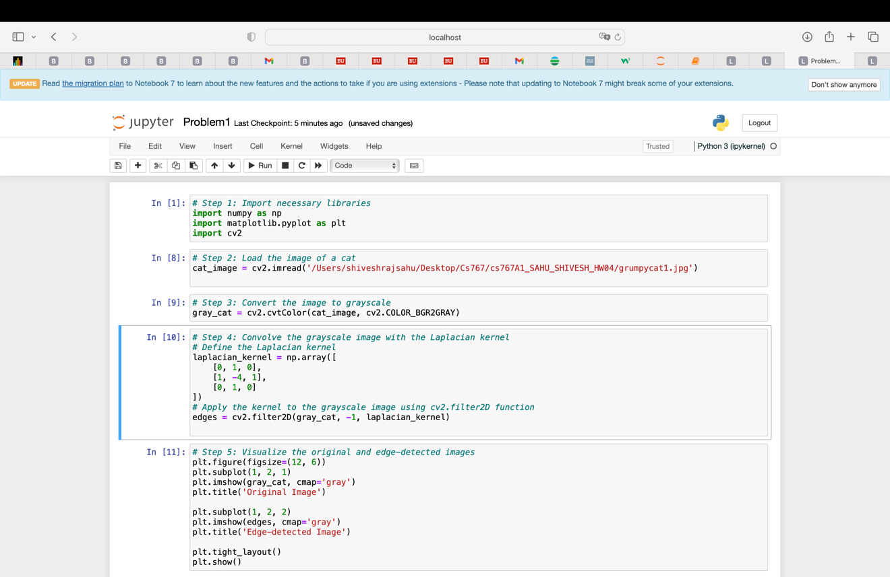

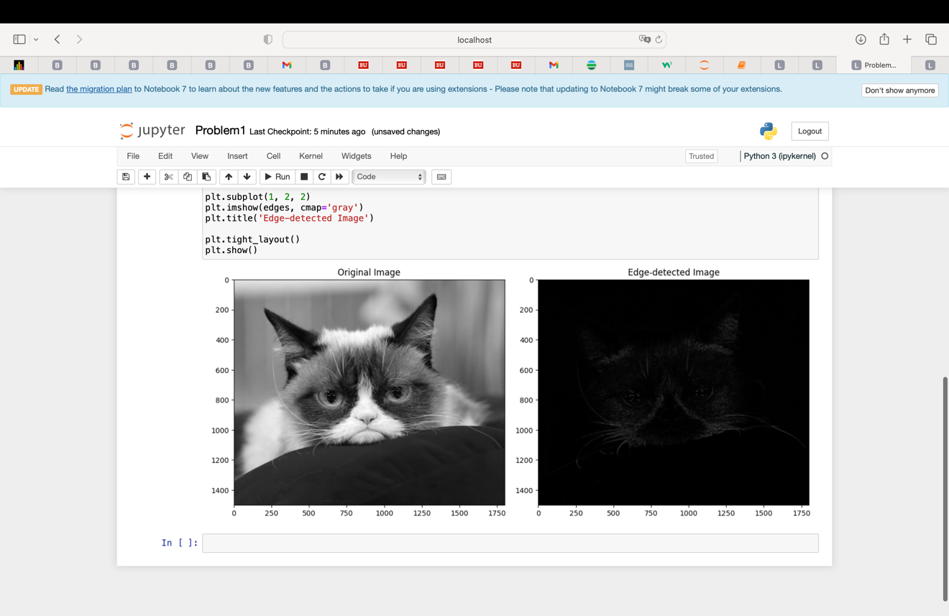

**Problem 2.** Modify kernel size in the second convolutional layer in the Small CNN for Classification of MNIST Images as defined on slide 41 of the latest version of the lecture notes. Let the second and the third Convolution layers use kernel size of (4,4). For the first layer keep kernel size of (3,3). Print the summary of your model. Please provide detailed explanation (calculation) for all numbers of trainable parameters.

**(25%)**

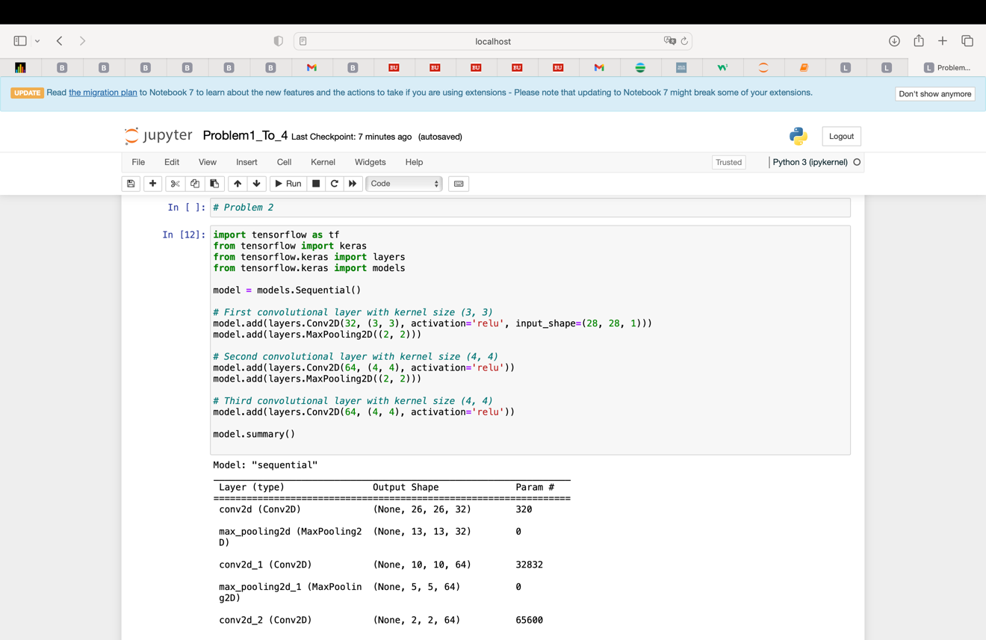

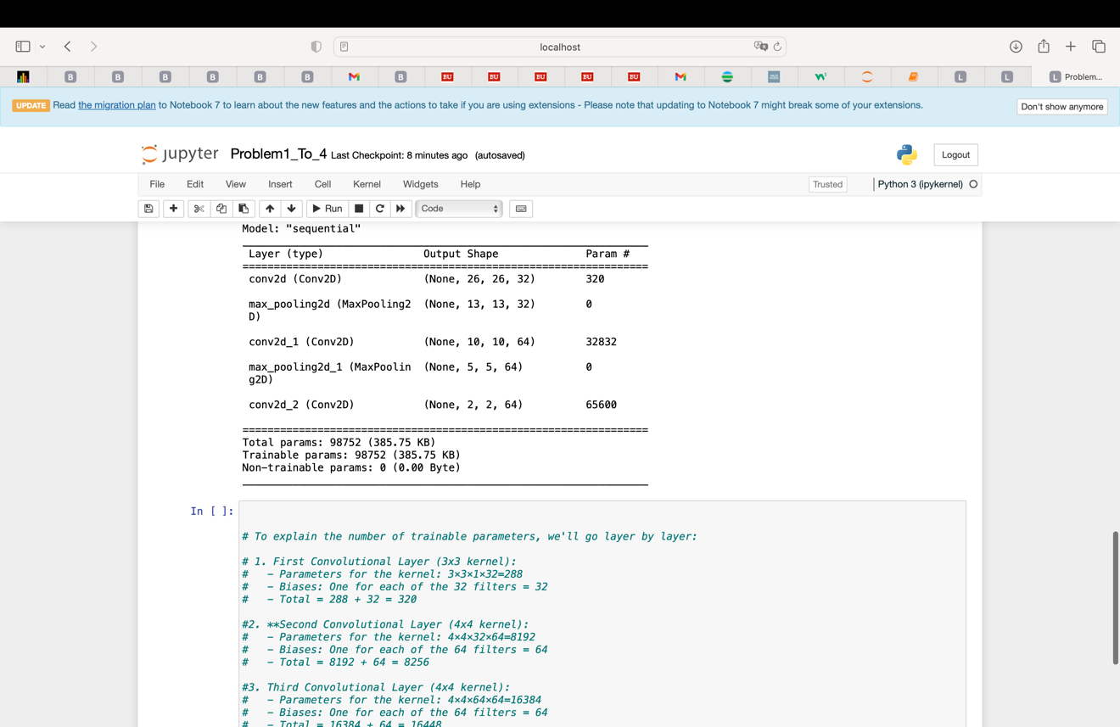

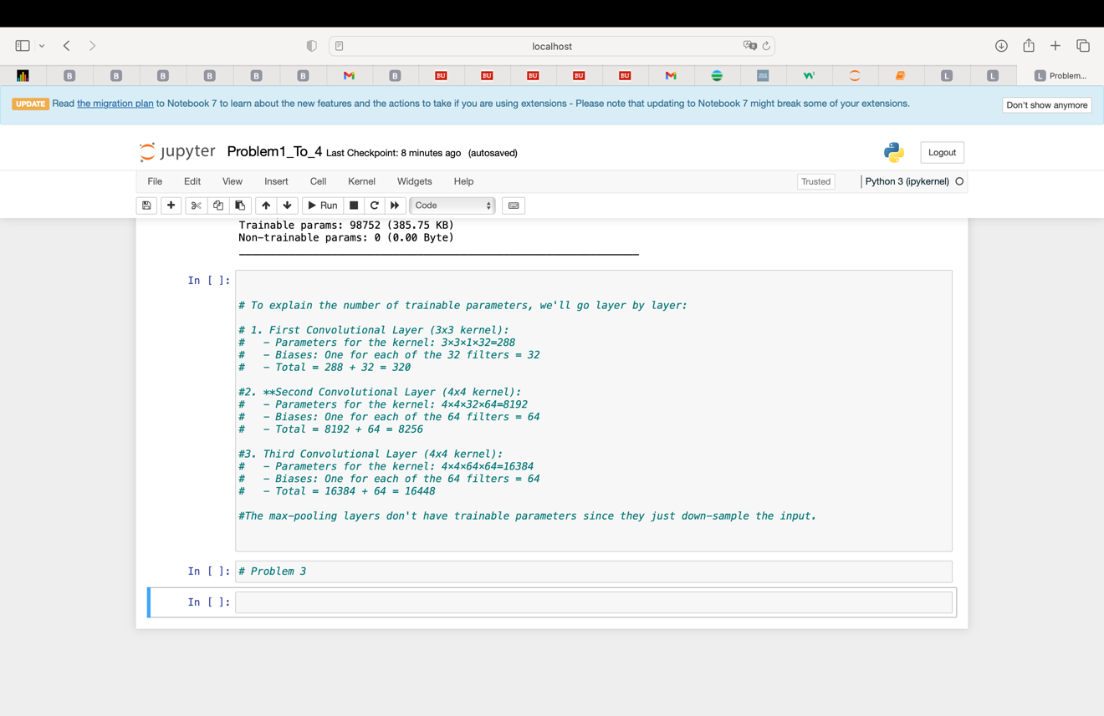

**Problem 3.** In the model with MaxPooling2D layer, as presented in the notebook 5.1-introduction-to-convnets.ipynb, change the size of the kernel on the first convolutional layer from 3x3 to 4x4, 5x5 and 6x6. Again, record and report the accuracy for different filter sizes. Plot evolution of accuracy with epoch. Select the best model.

**(25%)**

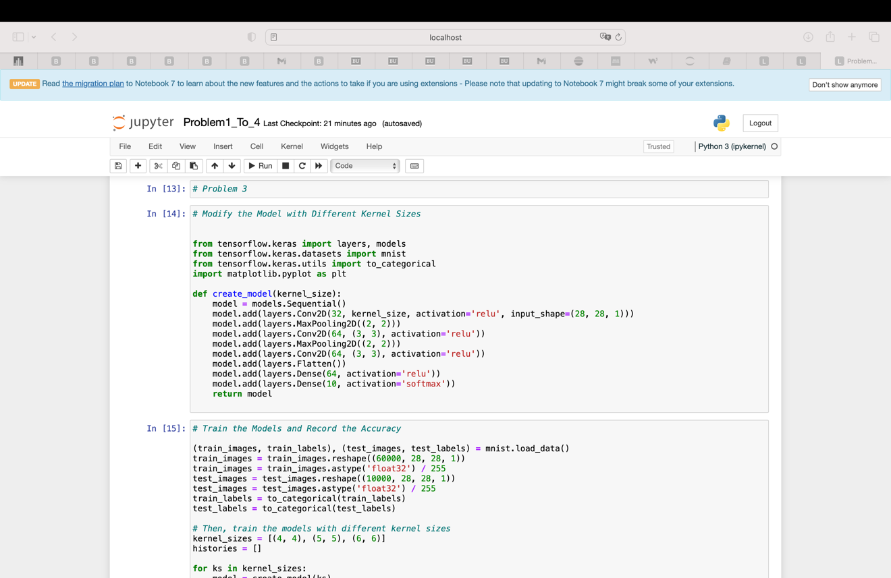

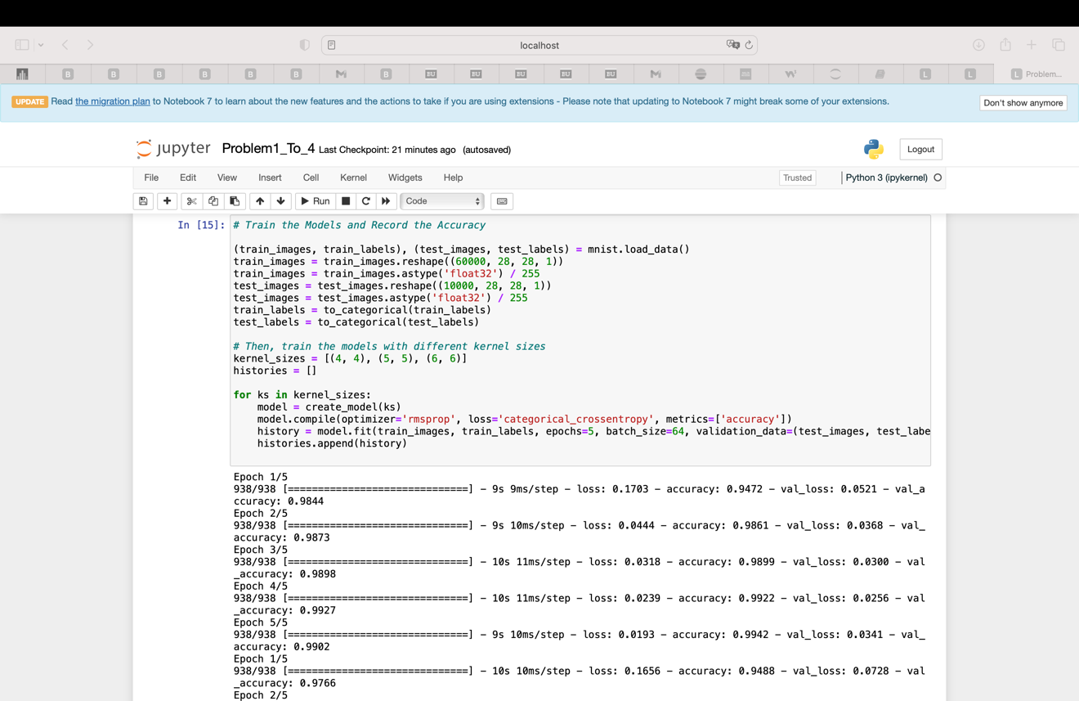

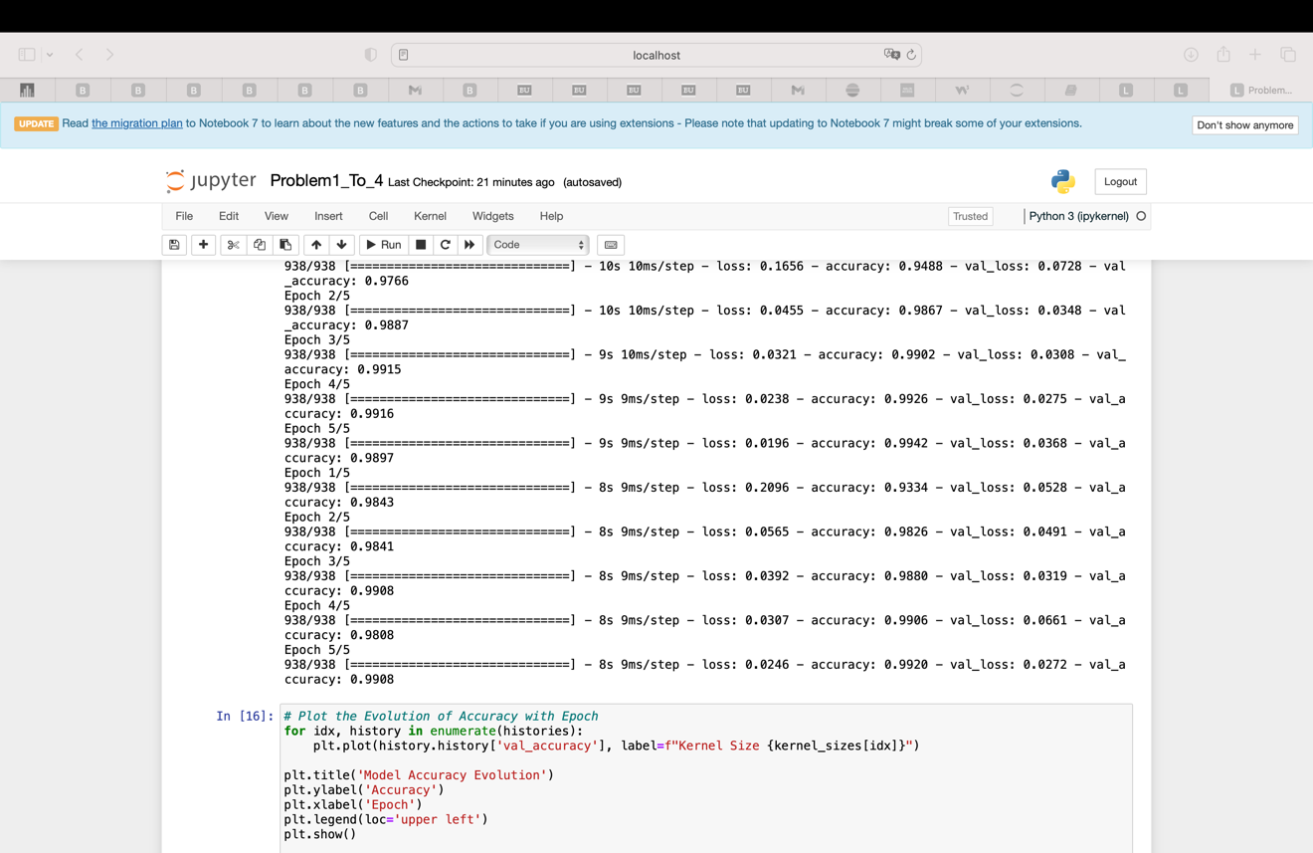

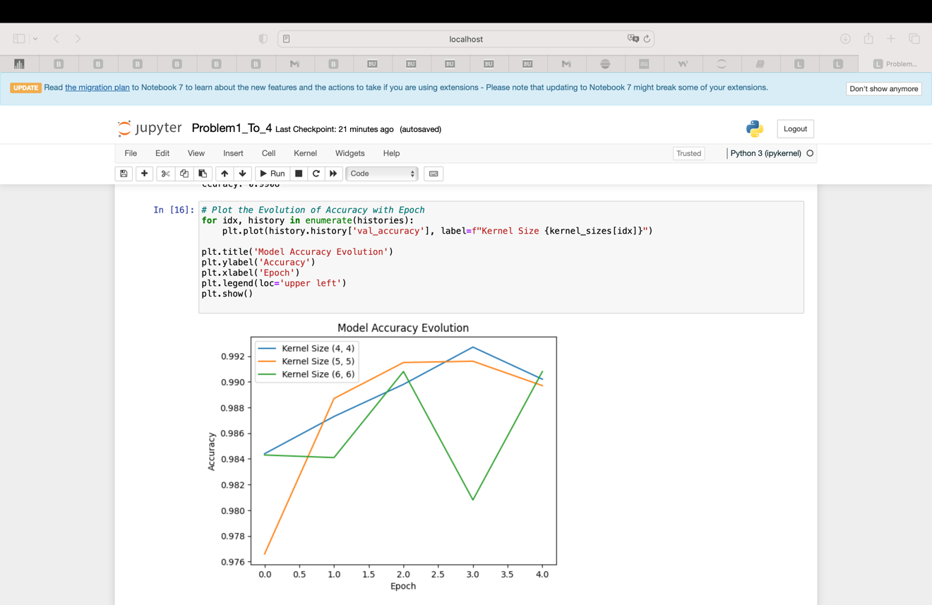

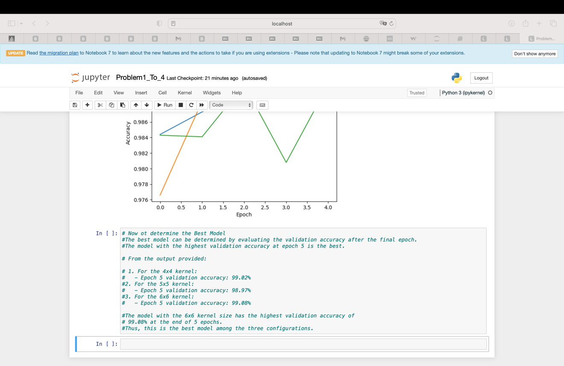

**Problem 4.** Use your own handwriting to create 2 images each of numbers 0, 1,2,3, 4, 5,6,7, and 8. Test the ability of the best model selected in problem 3 to recognize those numbers. Assess the accuracy of the model using just those 18 digits as the test set. Compare with the result of problem 4.

**(25%)**

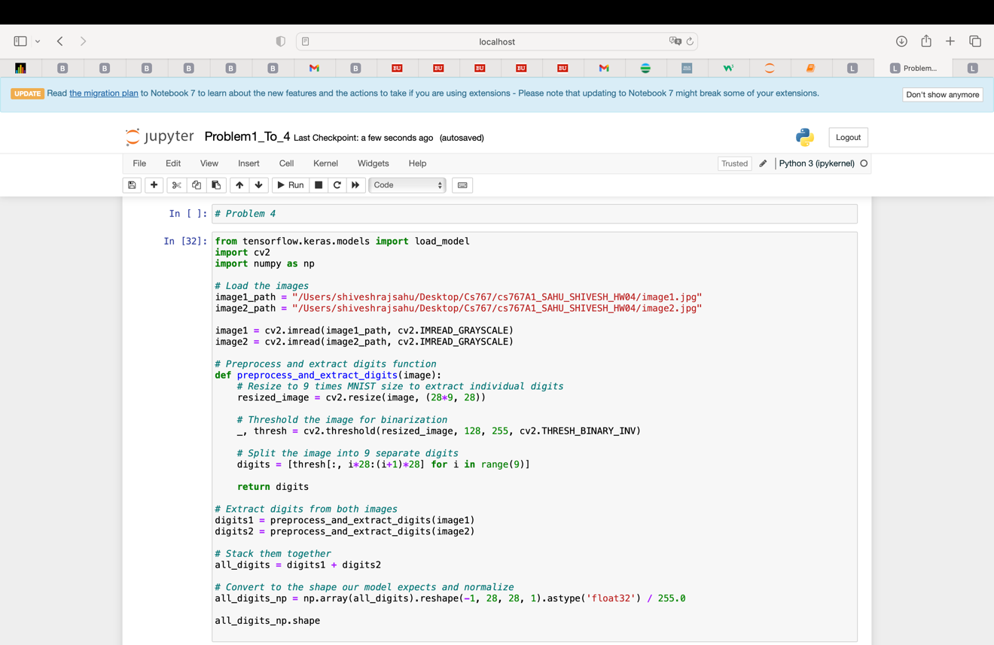

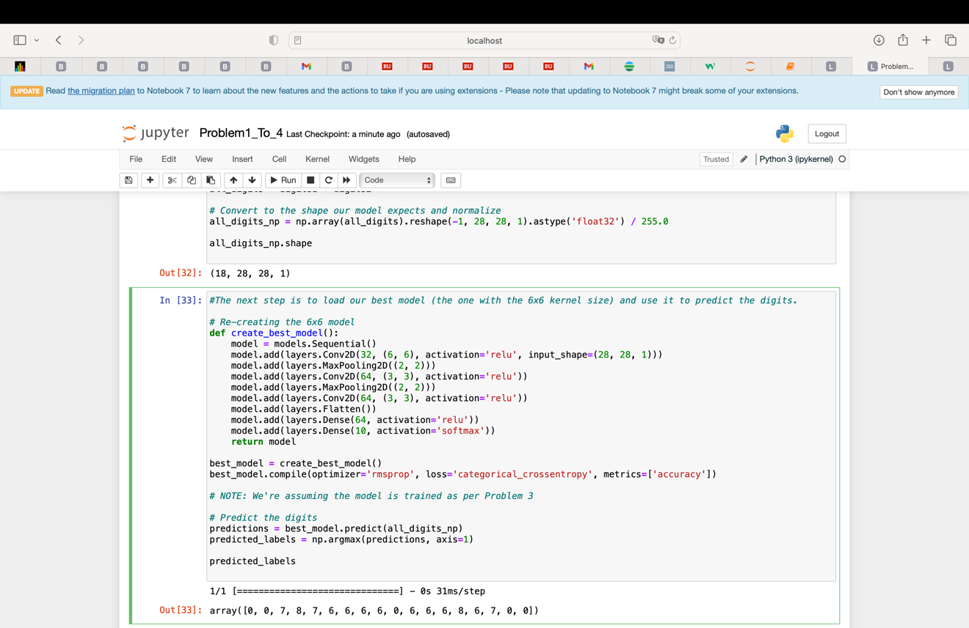

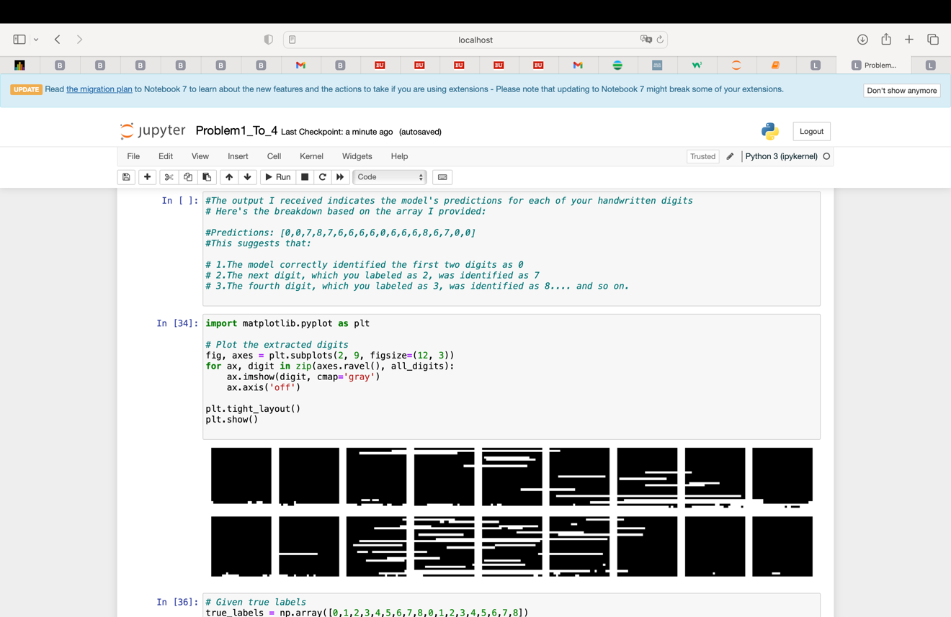

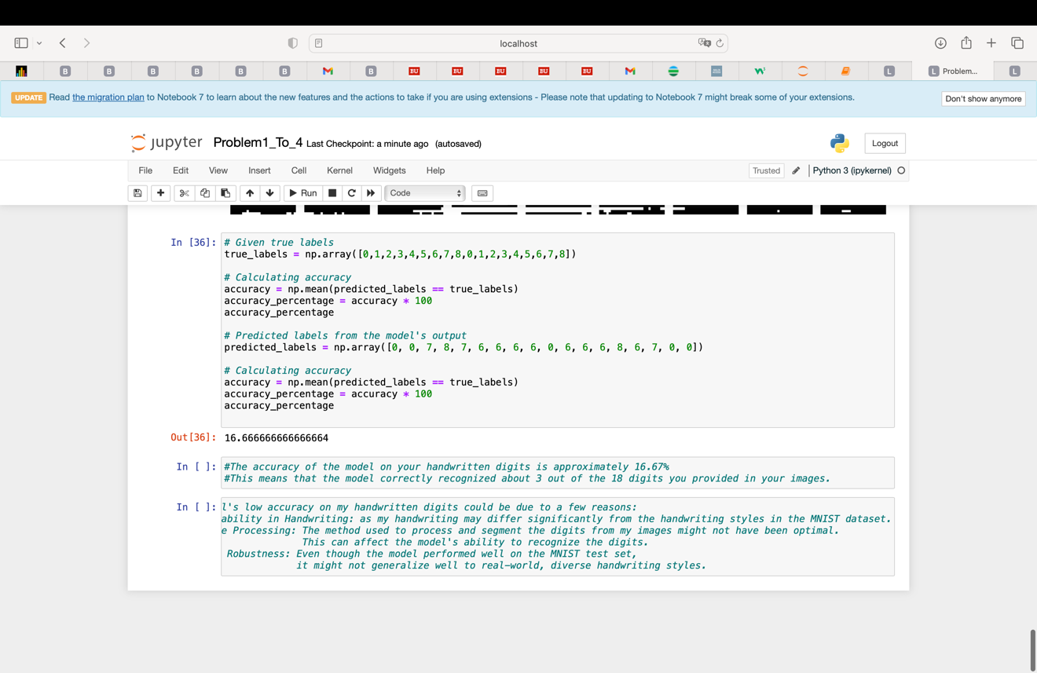

**Problem 5**. Please run every cell of the attached lab notebooks: Lab04a-introduction-to-convnets.ipynb and Lab04b_ReadImages.ipynb. Please provide both ipynb files and their HTML images.

**(25%)**

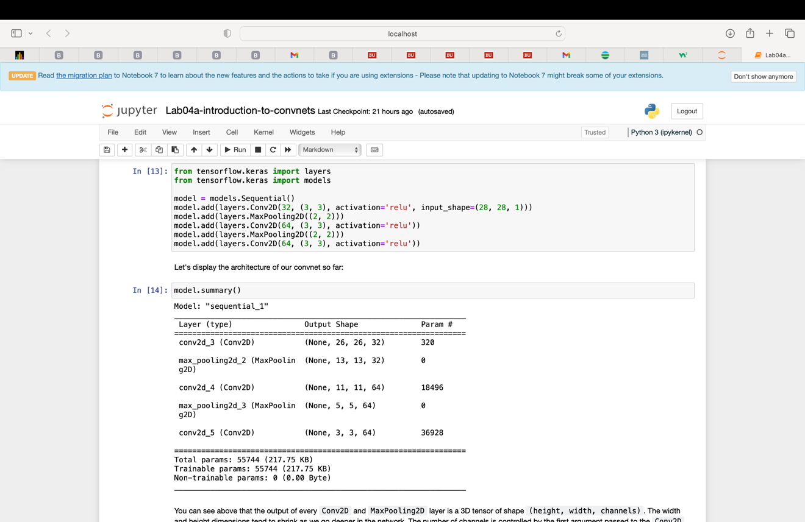

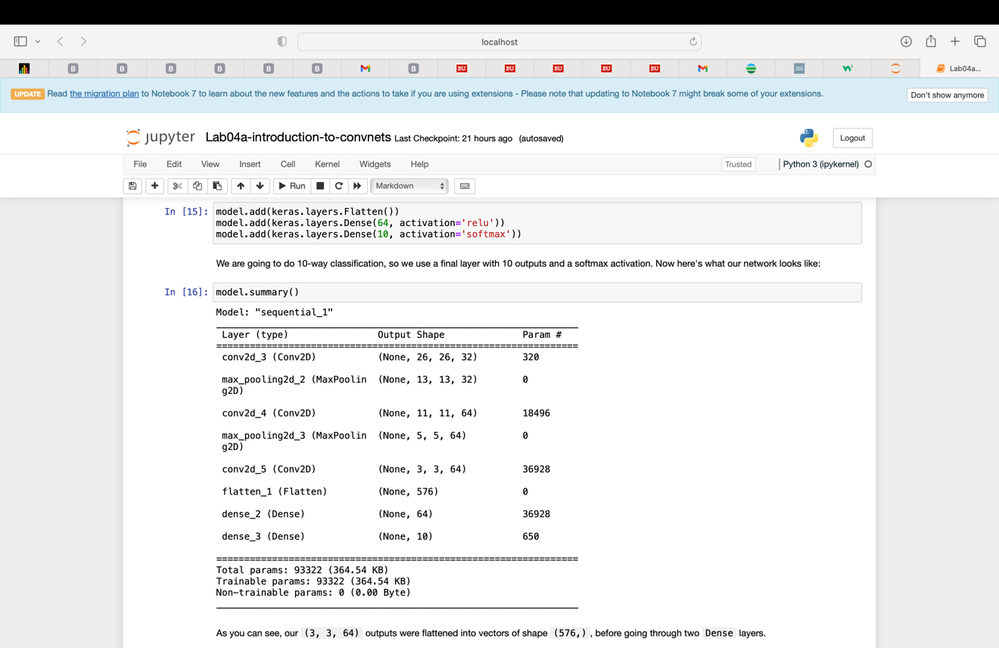

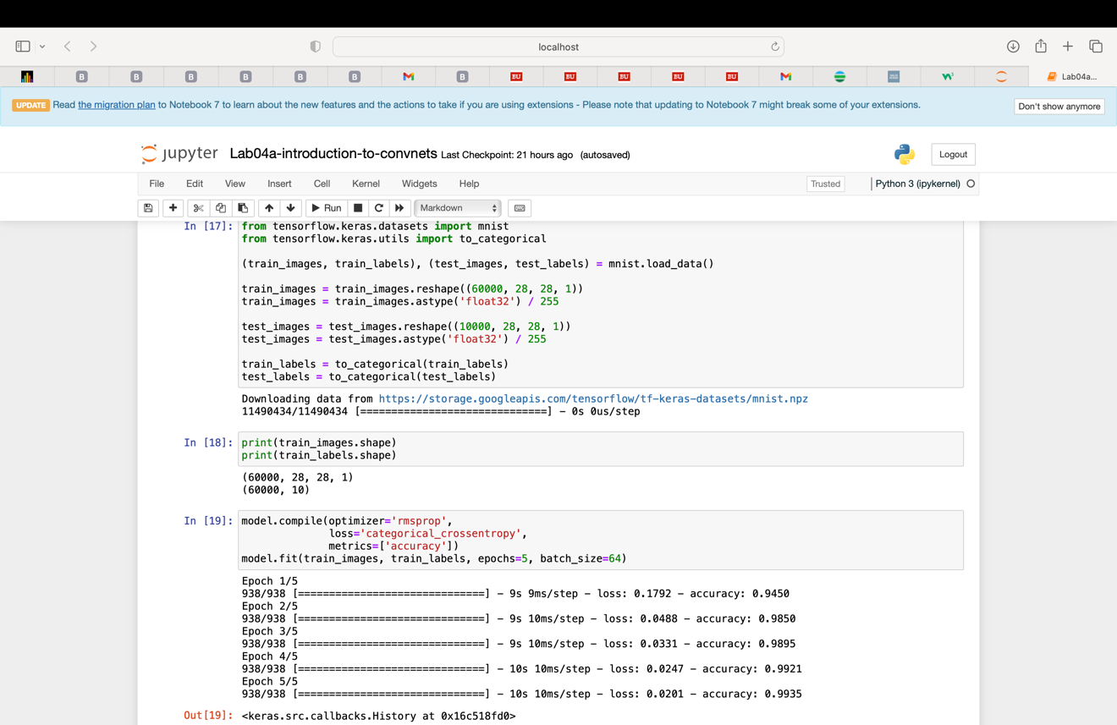

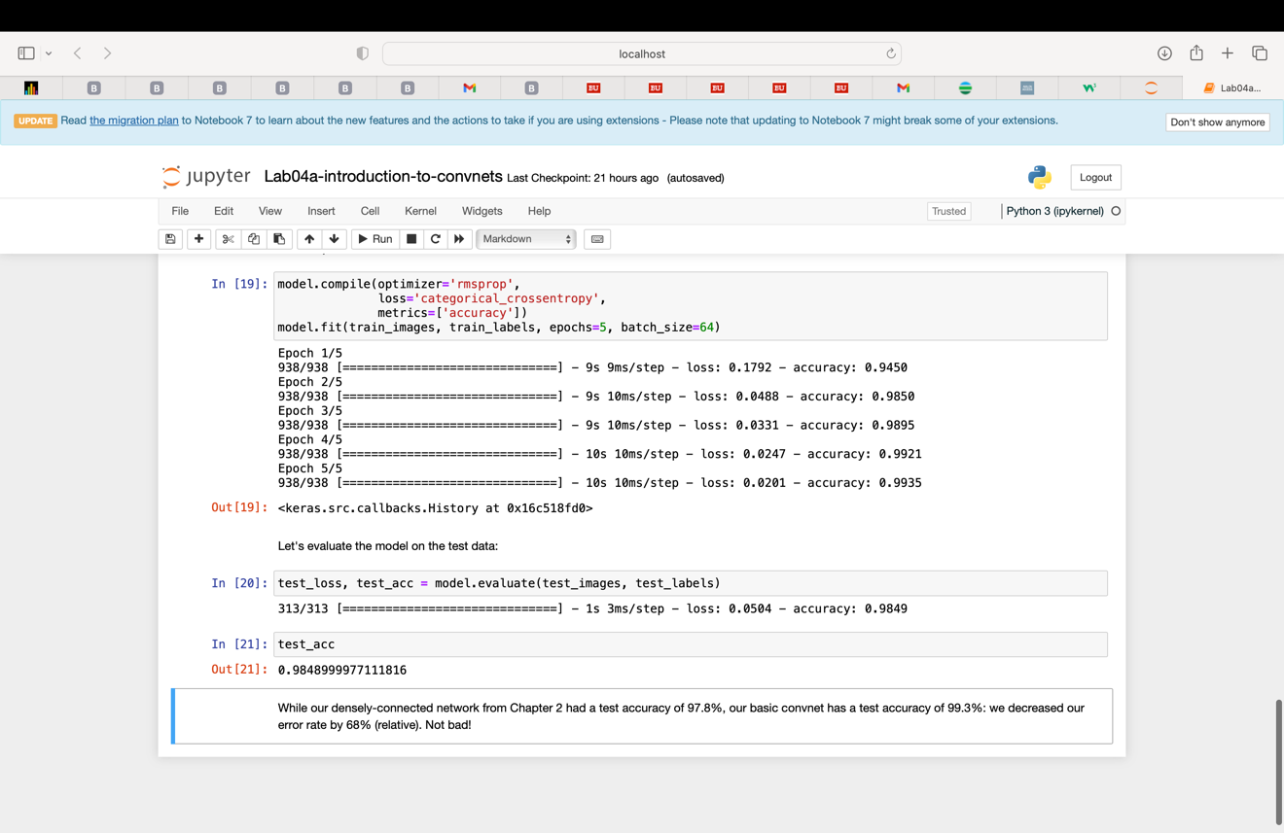

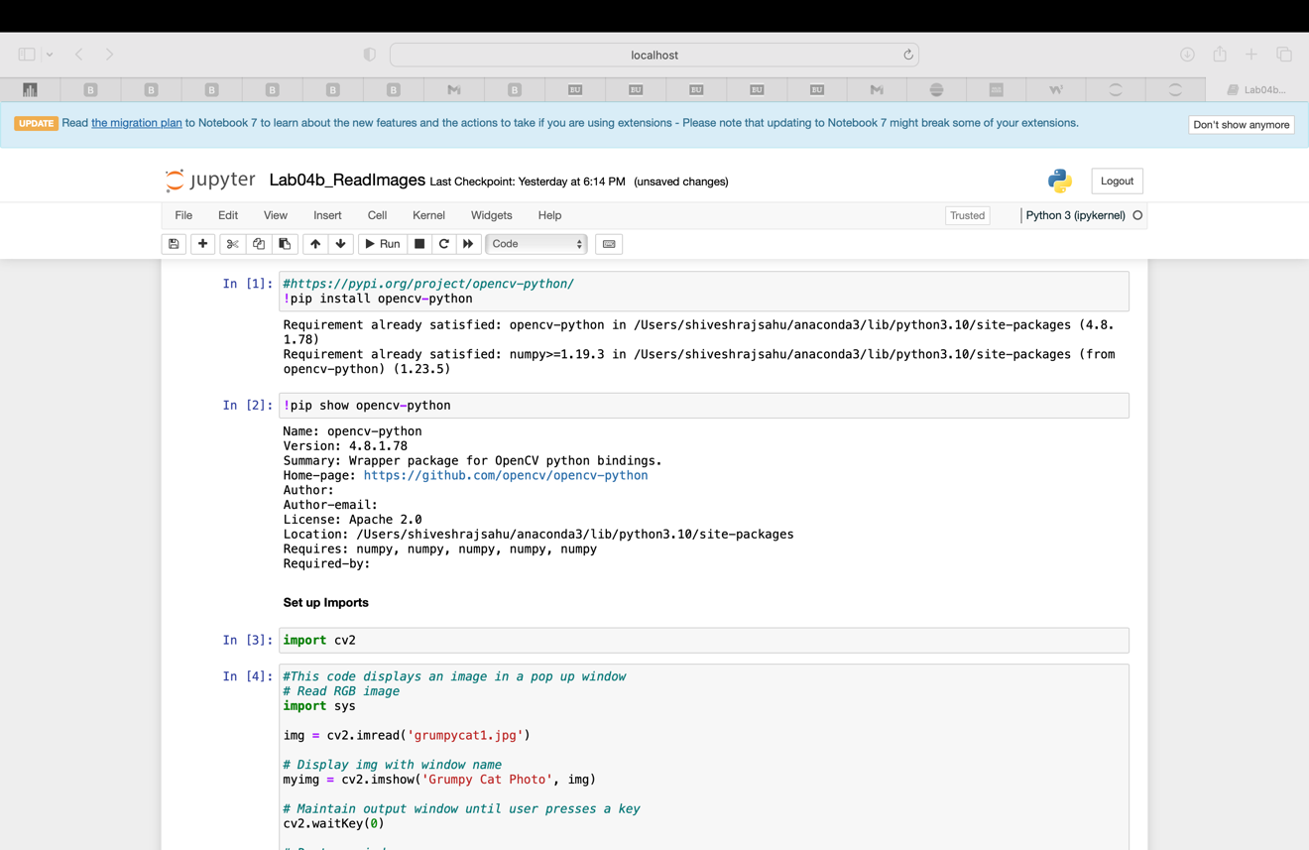

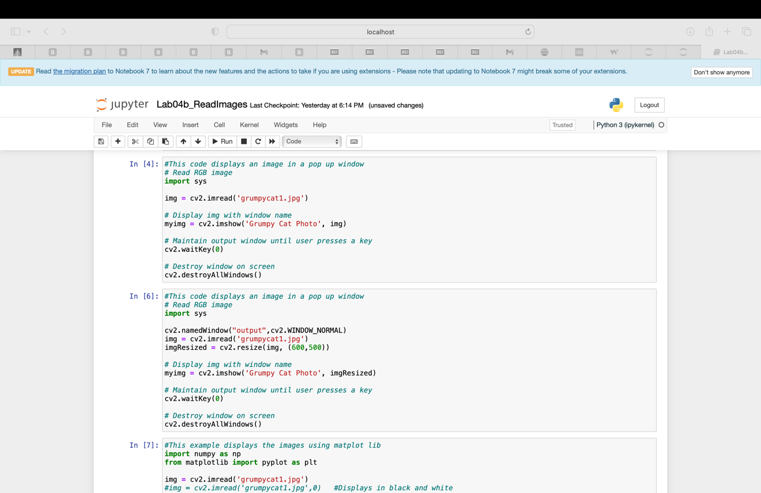

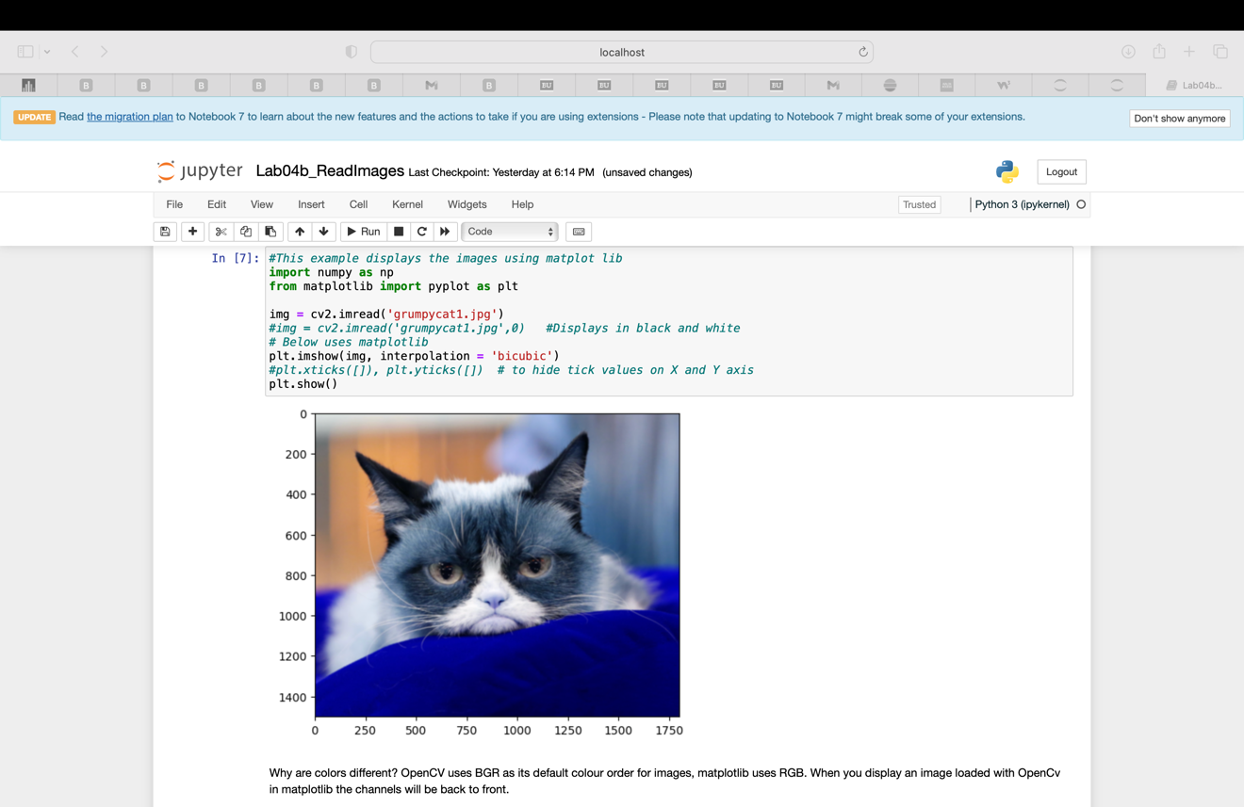

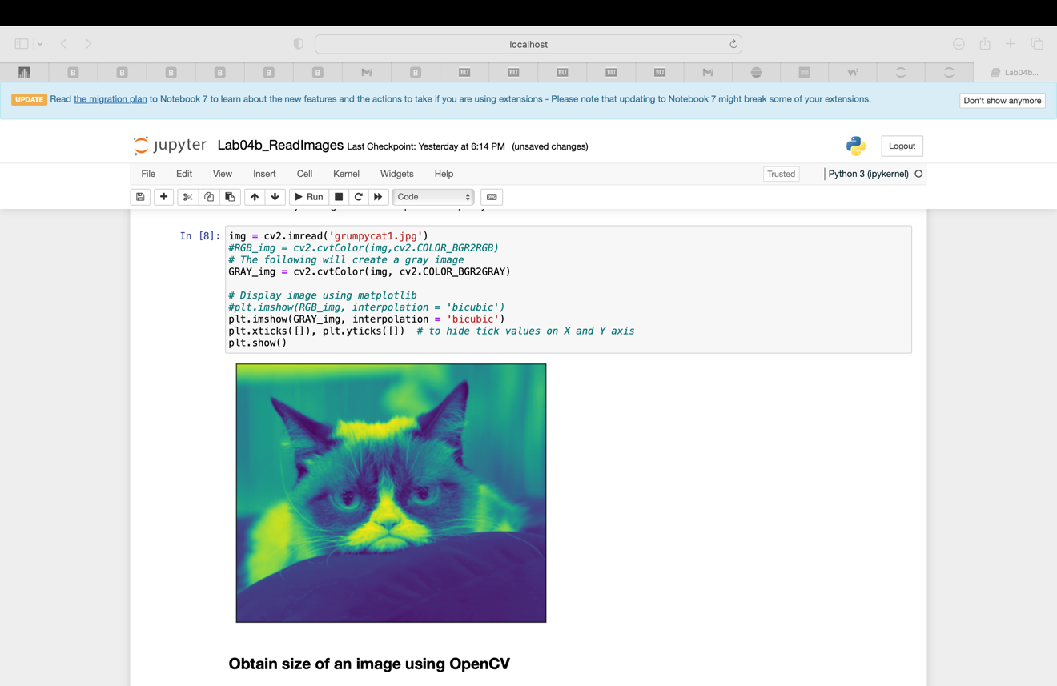

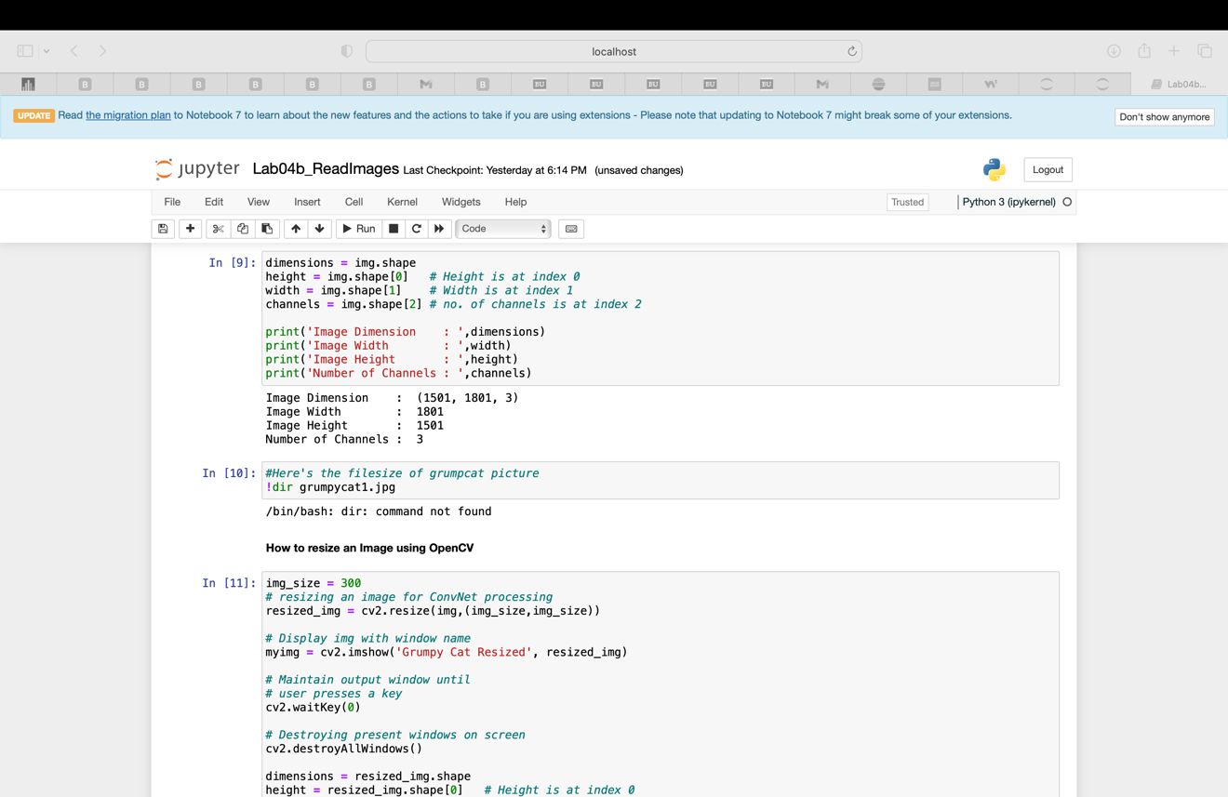

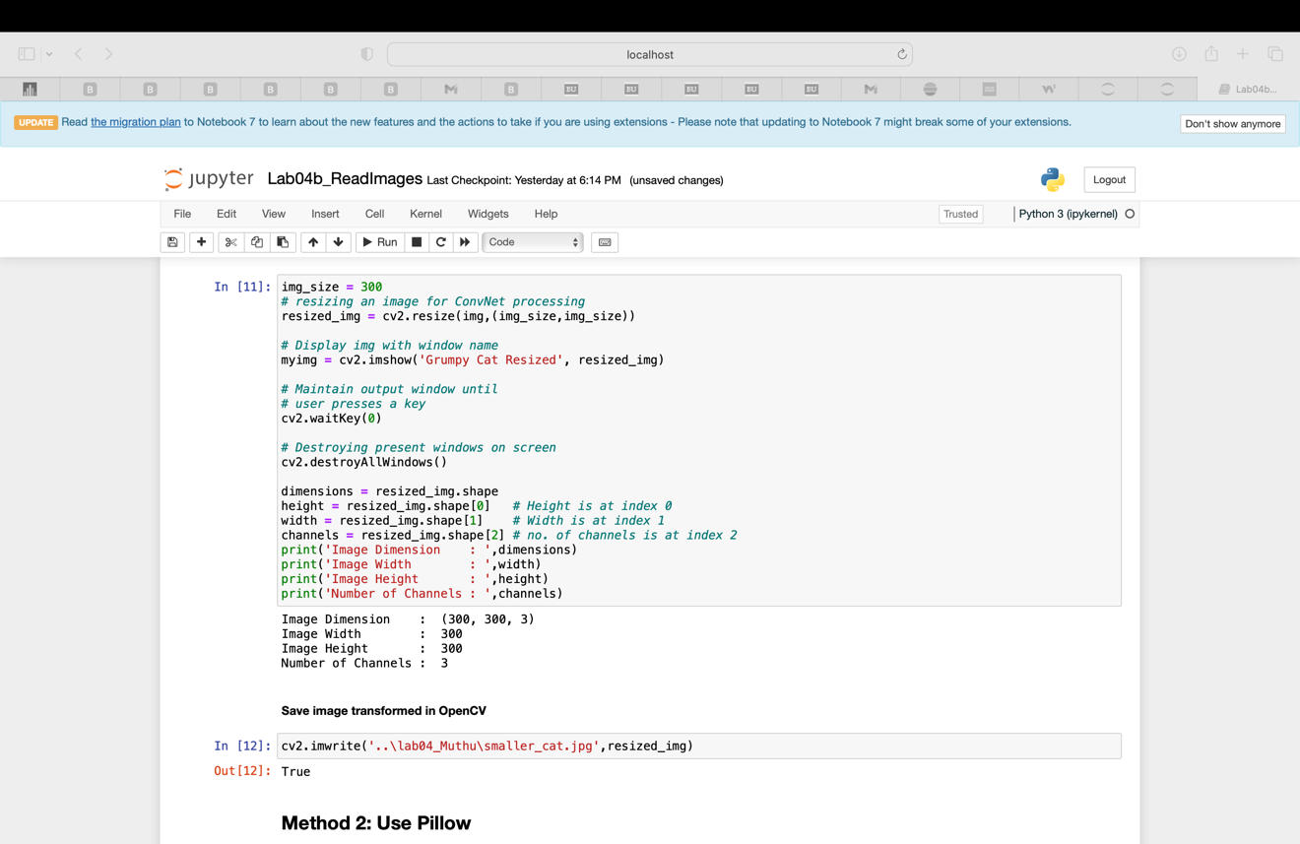

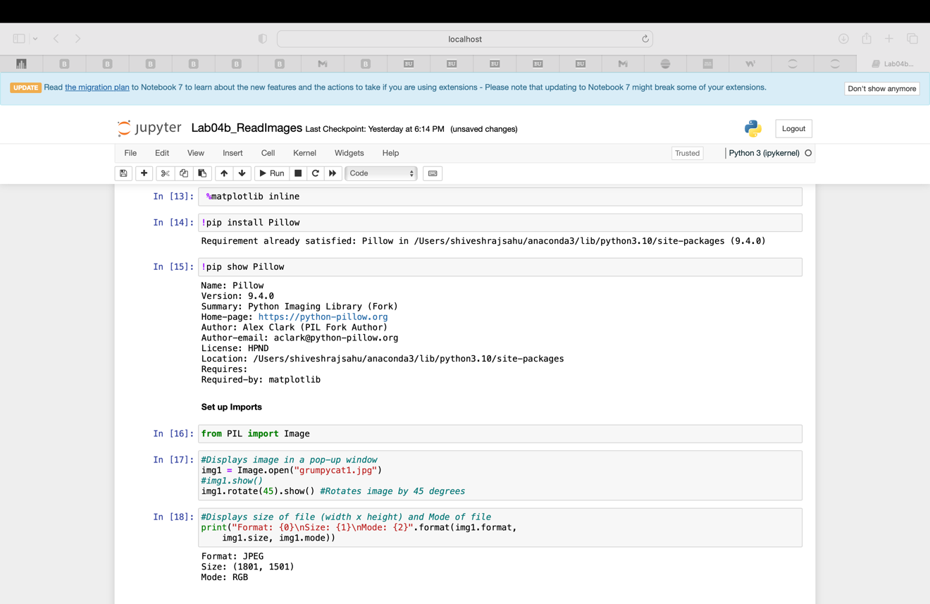

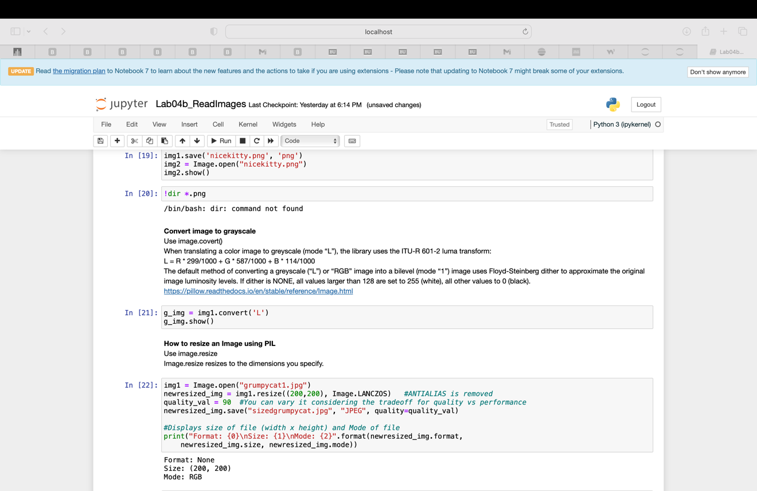



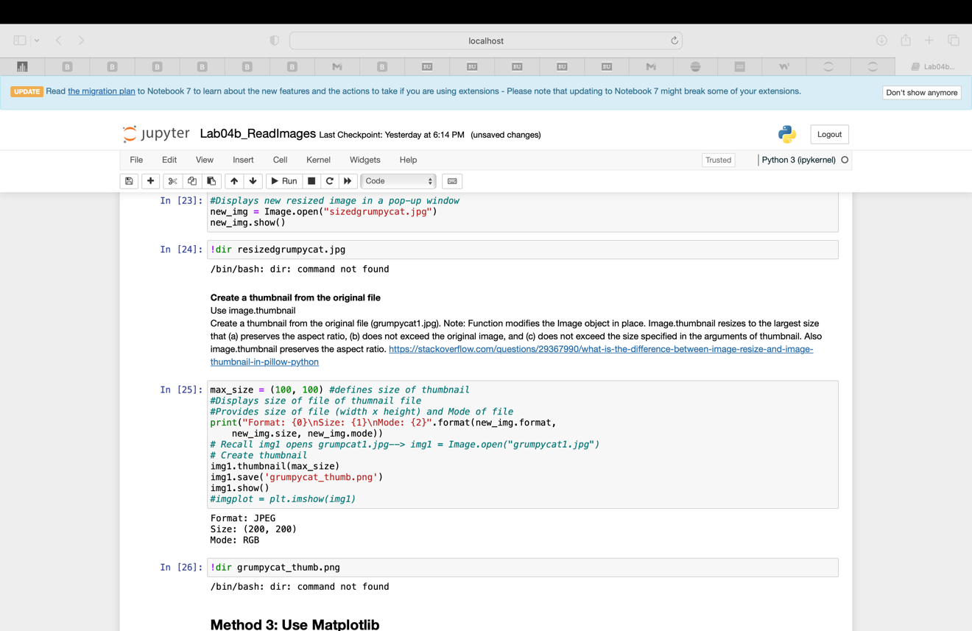

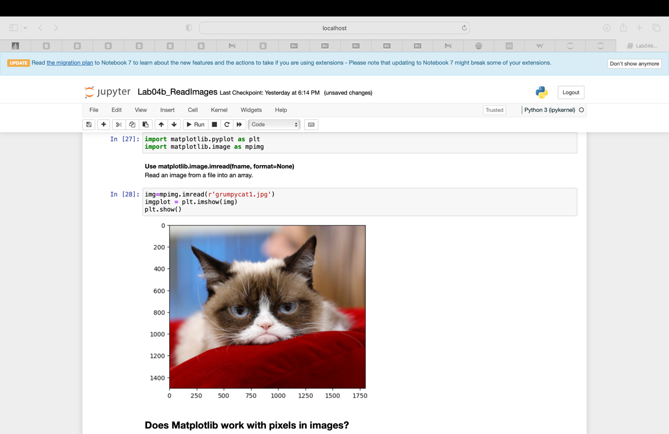

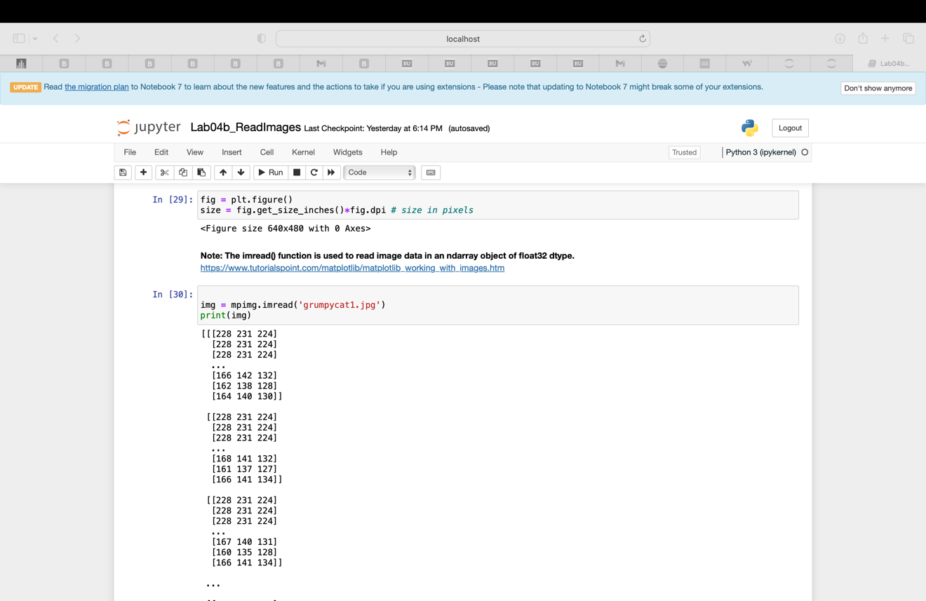

Your main submission should be one Jupyter notebook with solutions for problems 1 to 4 and its HMTL image. Please provide ipynb and HTML files of fully implemented lab notebooks. Please ZIP all files into a single archive.

Your notebook should include all results, images and comments.

Please place your last name, followed by your first name on the very top of your report.

Please, describe every step of your work as Python comments or notebook markdown cells. Please, present all intermediate and end results. If possible, package all problem solutions into one notebook.

If your notebook(s) contain(s) excessively long outputs please copy a meaningful and illustrative number of initial and/or final lines and paste those in a markdown (comment) cell. Then, delete the long output(s).